4TH OF JULY COOKOUT

We hosted a 4th of July cookout at our home this year. I had fun planning, decorating, and even doing some DIYs, so I wanted to share some photos from the event.

First up, the fireplace. I love everything about this and how it all looks together. It’s simple because I didn’t want to go overboard or have things too cluttered. The bunting consists of some red, white, and blue string lights from Target ($3), and a burlap banner that I found at Cost Plus World Market. The burlap fits perfectly with the rustic style that I love, and also it keeps the space from looking overwhelmingly red, white, and blue because it breaks up the color a bit. I actually hung the bunting using command hooks that I have ‘permanently’ underneath our mantle. Command hooks are great because you can remove them without causing damage, but I keep these ones up so I can change out bunting or banners for different occasions.

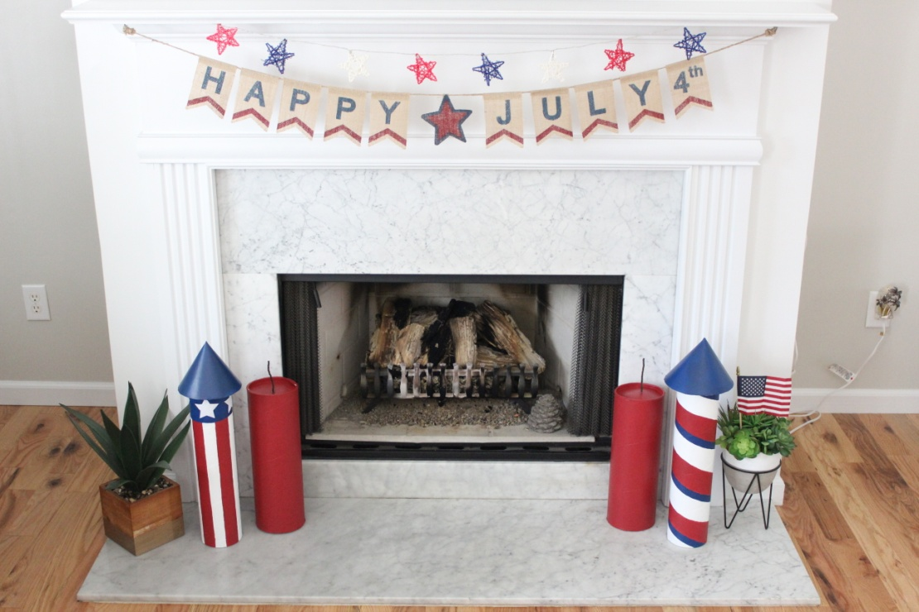

The last pieces for the fireplace are my DIY rockets and dynamite. These were honestly sort of a pain to make, but I’m so pleased with how they turned out that I’m glad I took the time and effort to make them. I’ll have them basically forever now, so I can use them again and again. I saw some inspiration pictures for DIY rocket décor on Pinterest [https://www.pinterest.com/pin/415034921901281713/] and wanted to try it out. Instead of using paper towel or toilet paper rolls to make these, I used some shipping tubes I had laying around which worked great, and allowed me to make them on a larger scale.

I had two shipping tubes to work with, so I cut each of them in half (carefully, using a large serrated kitchen knife) to give me four bases. I then sanded down the raw edges. Because one of the tubes was a little smaller and fatter, I decided the shape would work great for making sticks of dynamite, so I ended up with two rockets and two dynamites. I used satin acrylic paint and painters tape to make my designs. I had to do several coats and touch ups, which was the frustrating and time consuming part. The tops of the rockets are made out of poster board which I cut into circles and made into cone shapes, then attached with hot glue. The fuses on the dynamite are made from a rope-like string that I found in my craft supply collection. I ended up threading some floral wire through the string to allow it to stand up after it had been glued on. I’m very pleased with the result, and I loved these pieces as part of our party décor.

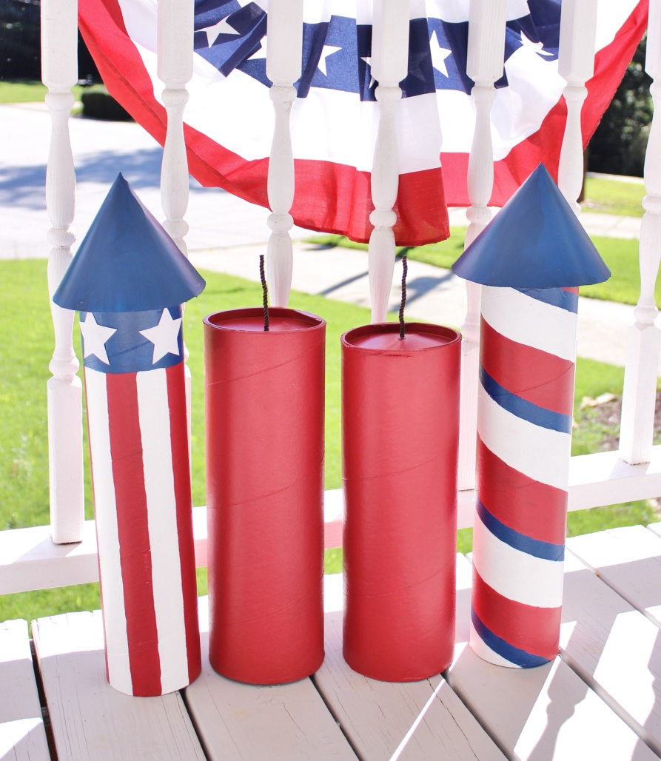

We had two tables for food set up. I had themed table clothes, napkins, and plates. I had a few party décor pieces around the food area like a banner, some balloons, and I put some flags and picks in mason jars to set on the tables as well. I like to have something on the table that’s not just food and can act as sort of a centerpiece.

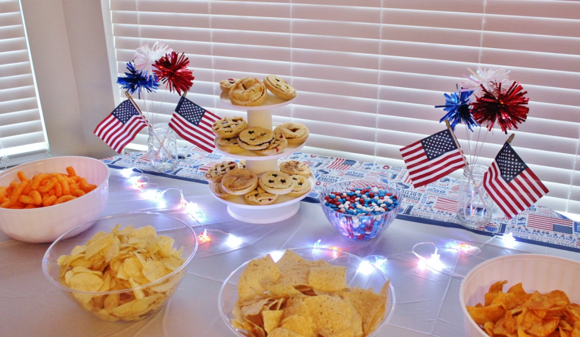

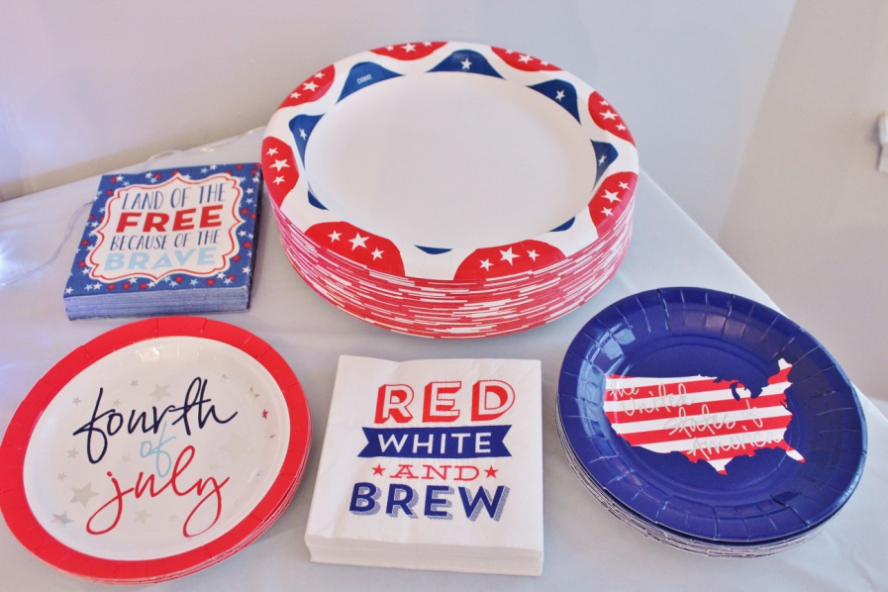

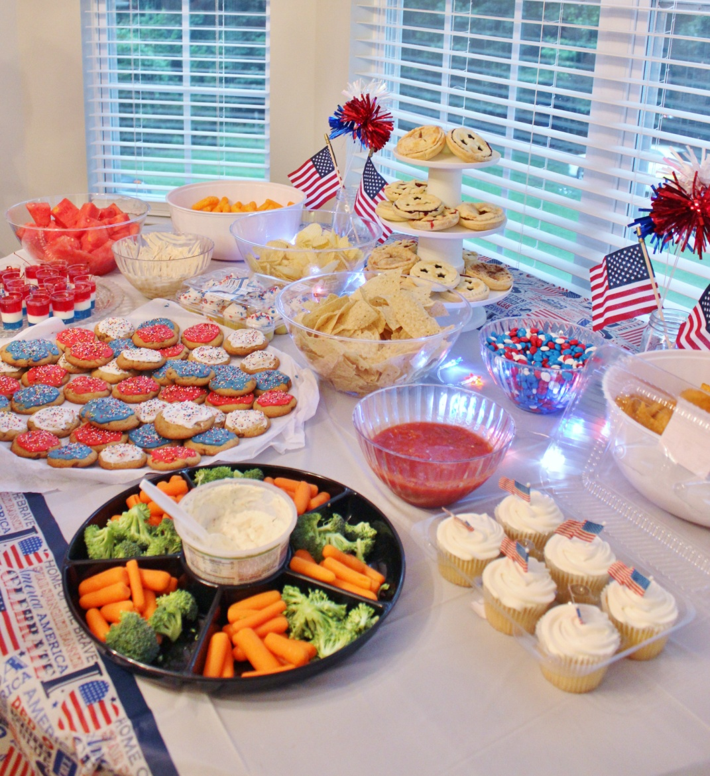

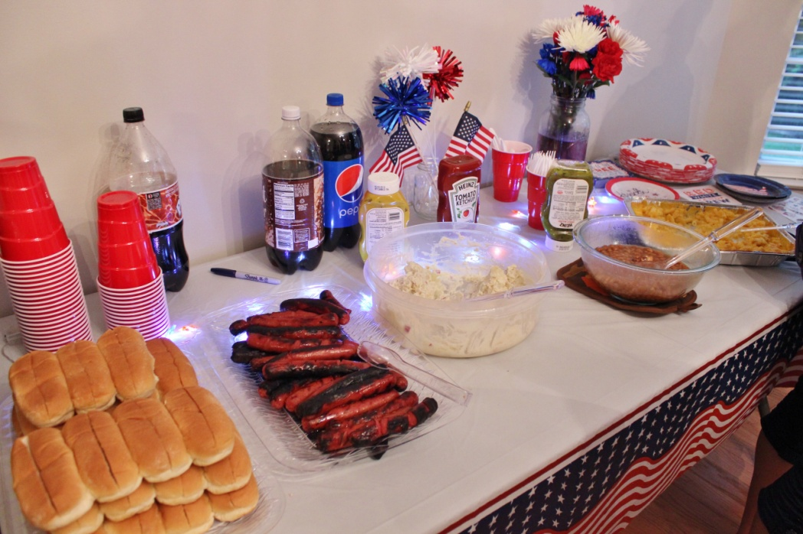

I got these battery powered string lights from the Dollar Tree, which I placed on the tables for a little something extra.

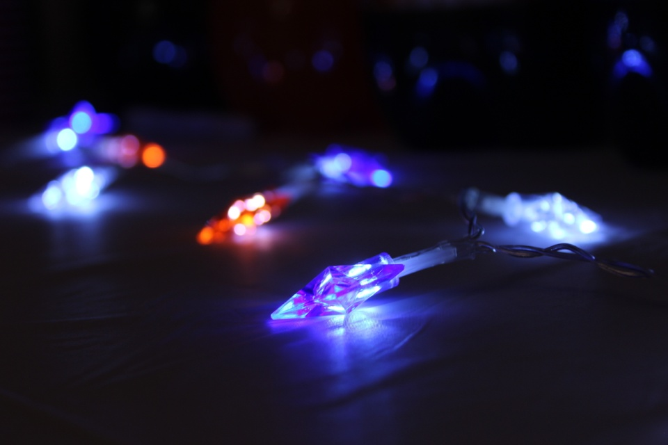

We have a chalkboard in the dining room that I’ll change for certain events and holidays, so I wrote something 4th related on it for our cookout. I copied this one straight from Pinterest. [https://www.pinterest.com/pin/AaZ59ILdEf1SdsRRX0re_atIm7t632nSoqRpGP2r3rDZDRPcOun1w3Y/]

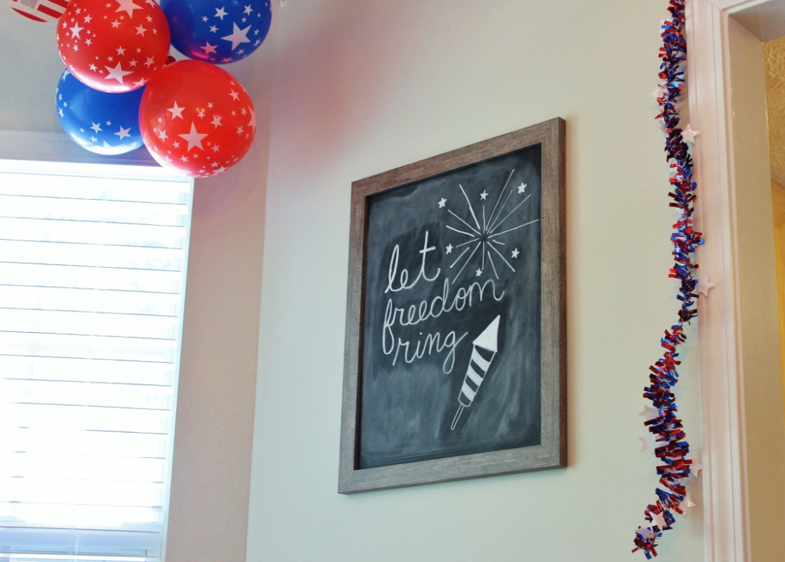

Added some balloons around the banner in the dining room and in the living room, some garland around the door frames, and the party decorations were done.

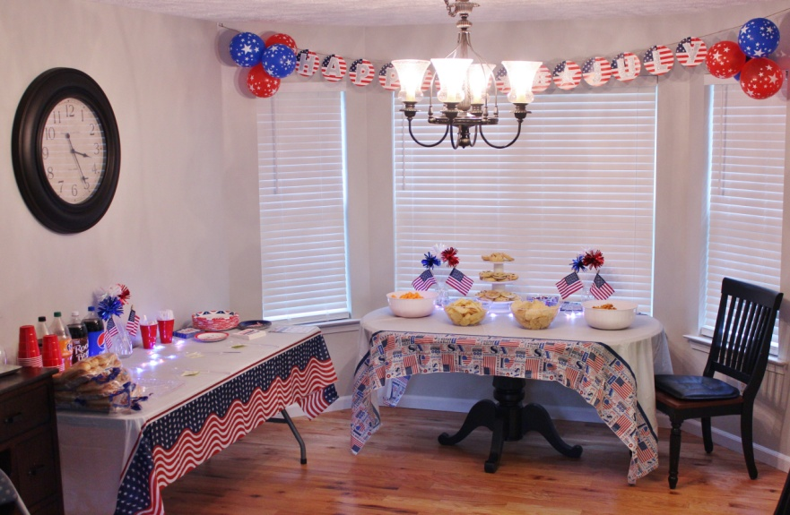

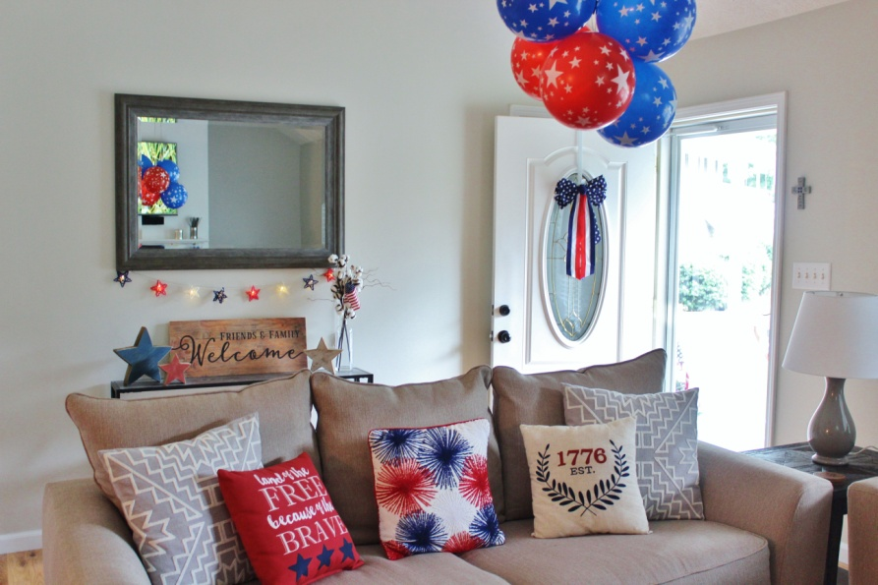

We kept the food very simple and traditional with some grilled hotdogs, baked beans, potato salad, and mac & cheese for the main course/sides. We also had a variety of chips & dips, a veggie plate, watermelon, and some desserts.

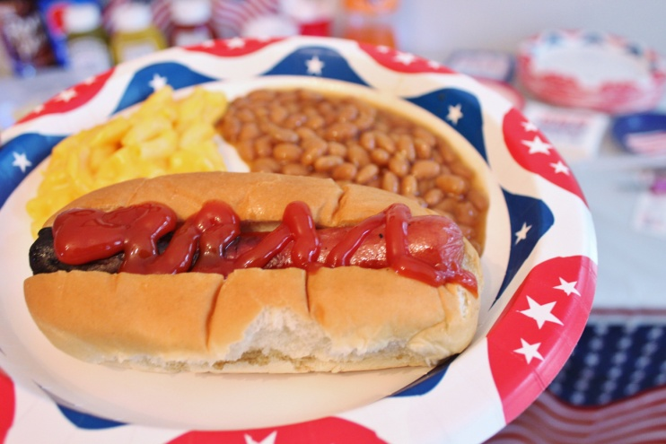

One of my favorite desserts had to be the mini mason jar pies I made. I got the recipe off of a video I saw on Youtube [https://www.youtube.com/watch?v=7umDrAzKlZI] last year, and they’re the cutest things. I actually made them for the first time last year and decided to make them again for our cookout this year.

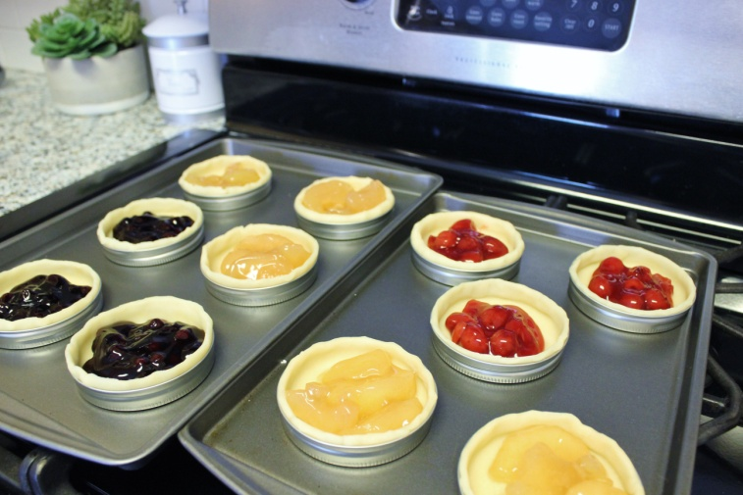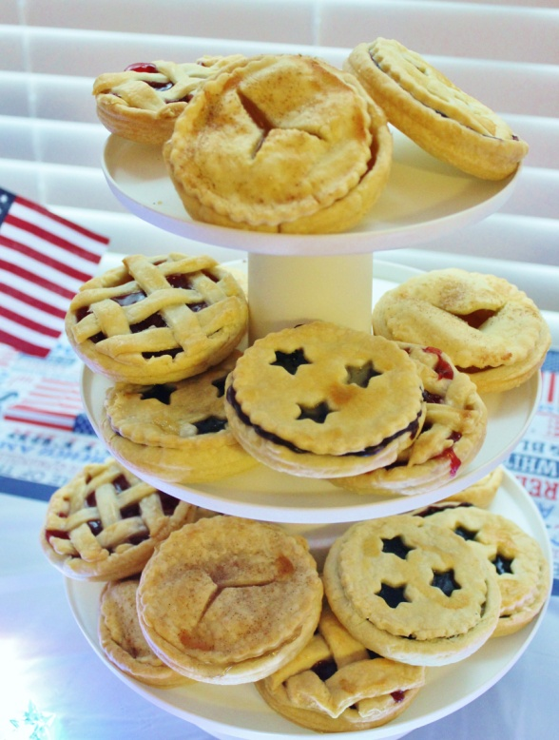

They’re easy to make (using premade pie crust and cans of pie filling), but dressing them up for the holiday made them extra festive.

My aunt also made some Jello firecracker cups [https://www.pinterest.com/pin/288511919870342542/] and red, white, and blue cookies to add to our themed desserts.

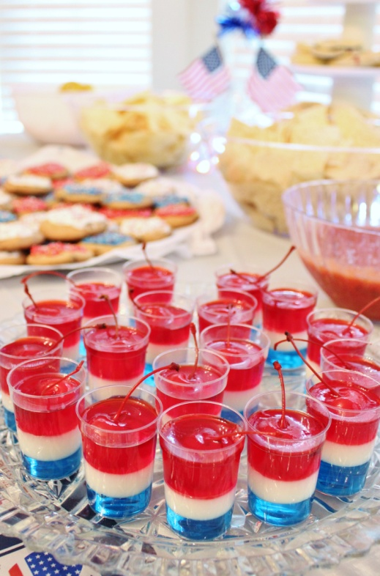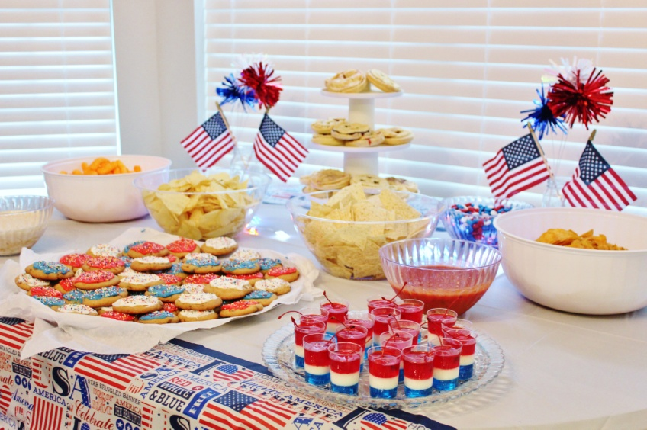

We had a classic rock station playing on Pandora, and we all chipped in to get some fireworks. I had bomb pops to eat during the fireworks, too, but unfortunately I forgot about them.

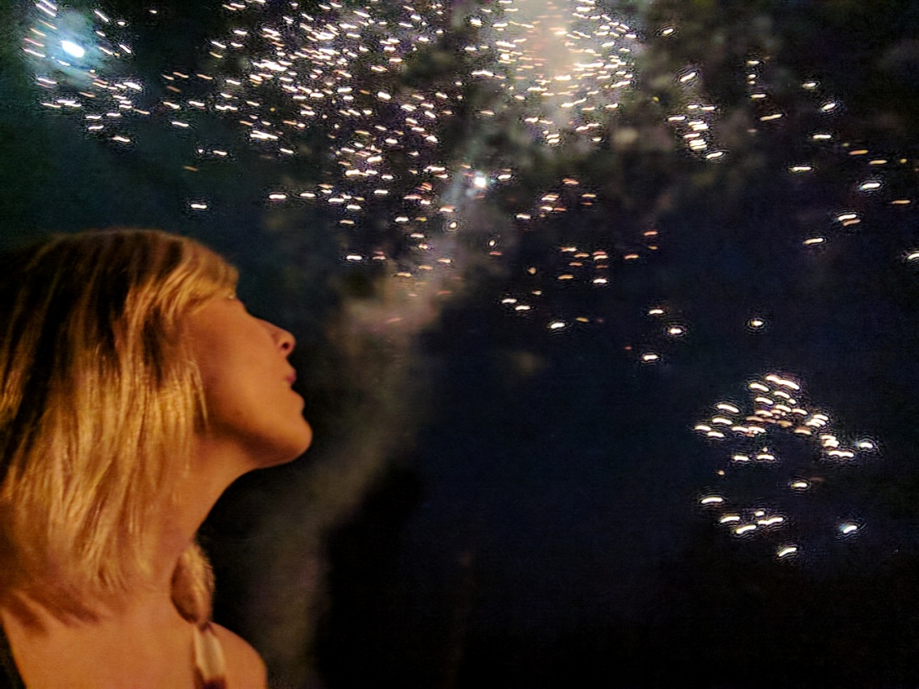

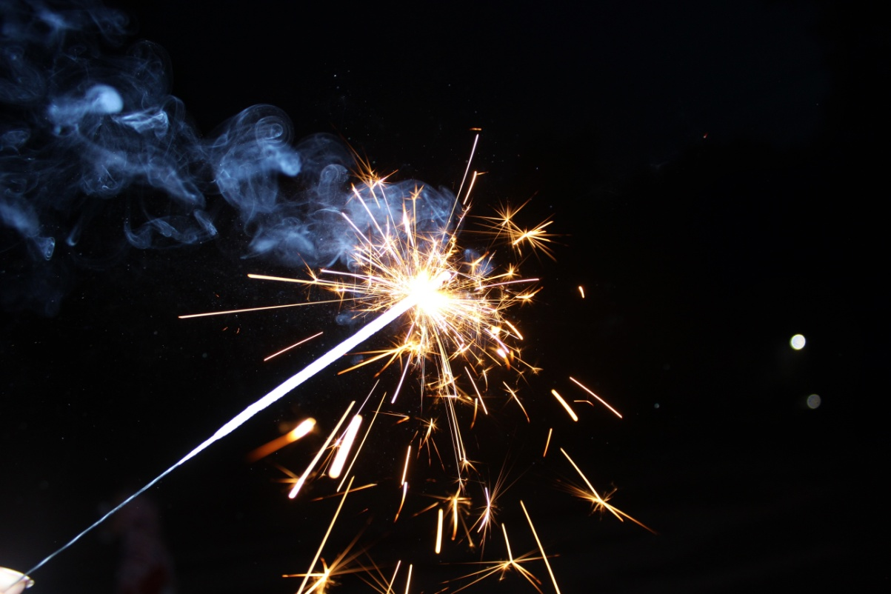

I’m so happy that everything turned out nice. Everyone had a great time, and it was wonderful to spend the day celebrating with family.